[One in six](https://jamanetwork.com/journals/jamapediatrics/fullarticle/2724377?guestAccessKey=f689aa19-31f1-481d-878a-6bf83844536a) youth aged 6-17 experience a mental health disorder each year in the United States, yet only half of youth with mental health conditions received any kind of treatment in the past year (NAMI).

St. Louis Public Schools provides students with mental health services by school-based staff as well as trained mental health providers from community partners. If your student needs help or is in crisis, it is critically important to obtain professional help.

Crisis Lines

National Suicide Prevention Lifeline. Call-Text or Chat 988.

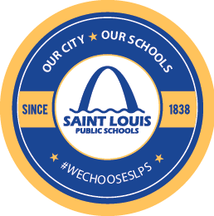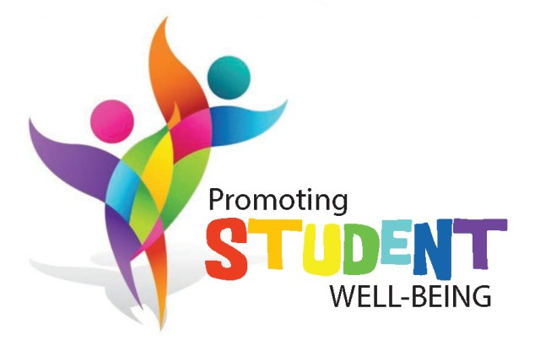

Behavioral Health Response.24-hour St. Louis-based crisis support, telephone counseling & resources. Call (314) 819-8802, text BHEARD to 31658, or chat online at bhrstl.com

KUTO Crisis Helpline. Kids under 21.

(314) 644-KUTO (5886). Staffed by trained youth volunteers every day after 4:00 pm. Trevor Project Helpline for LGBTQ youth. Call 1-866-488-7386 or text START to 678- 678.

Same Day Access to Mental Health Services

BJC Behavioral Health. 1430 Olive, Suite 400, St. Louis, MO 63103. (314) 206-3783. Open

Monday through Friday, 8 a.m. - 5 p.m. Hopewell Center (Lacy Clay Center for Children’s Health). 5647 Delmar Blvd., St. Louis, MO 63112.

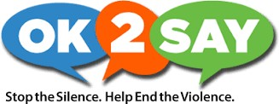(314) 531-1770. Open Monday through Friday, 8:30

a.m. to 5 p.m.

SSM Health Behavioral Health Urgent Care. 12355 DePaul Drive, Suite 150, St. Louis, MO 63044. (314) 344-7200. Open seven days a week from 9:00 a.m. to 7:00 p.m.